Haroutun Haroutunian

Professor Berhe

ECE 443L

3 April 2022

Lab 5: Monostable Multivibrators

**Figure 5.1: Monostable Multivibrator with 2 NOR gates @ 25ms Period, 1ms Pulse Width & T = 6\*tau**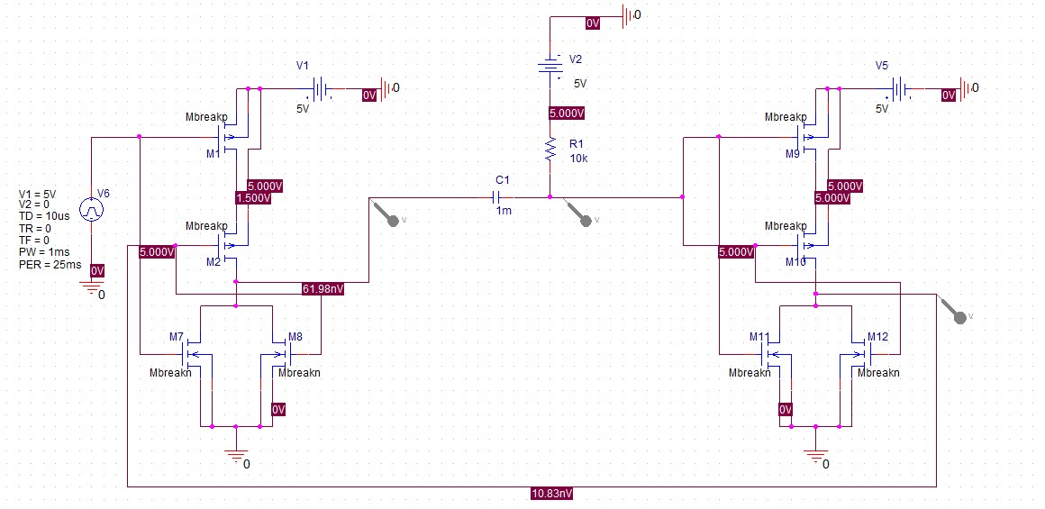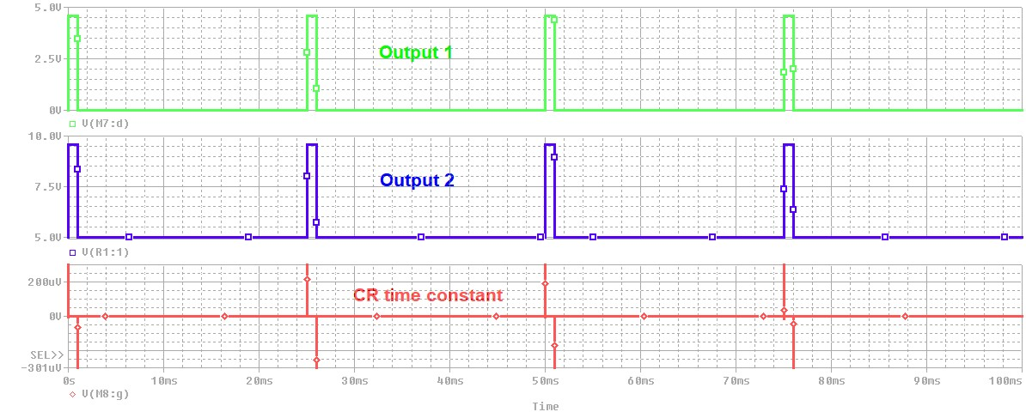

**Figure 5.2: Monostable Multivibrator with 2 NOR gates @ T = 6\*tau waveforms**

**Figure 5.3: Monostable Multivibrator with 2 NOR gates @ T = 6\*tau cursor**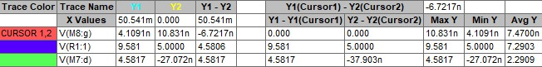

**Figure 5.4: Monostable Multivibrator with 2 NOR gates @ 25ms Period, .5ms Pulse Width & T = 12\*tau**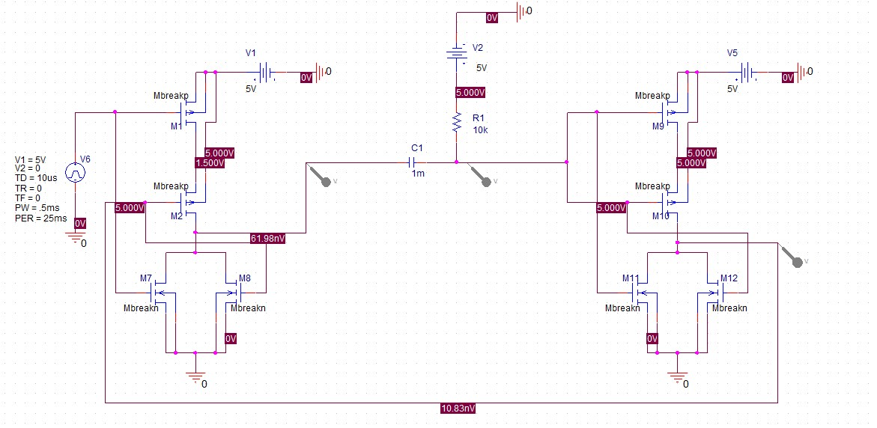

**Figure 5.5: Monostable Multivibrator with 2 NOR gates @ T = 12\*tau waveforms**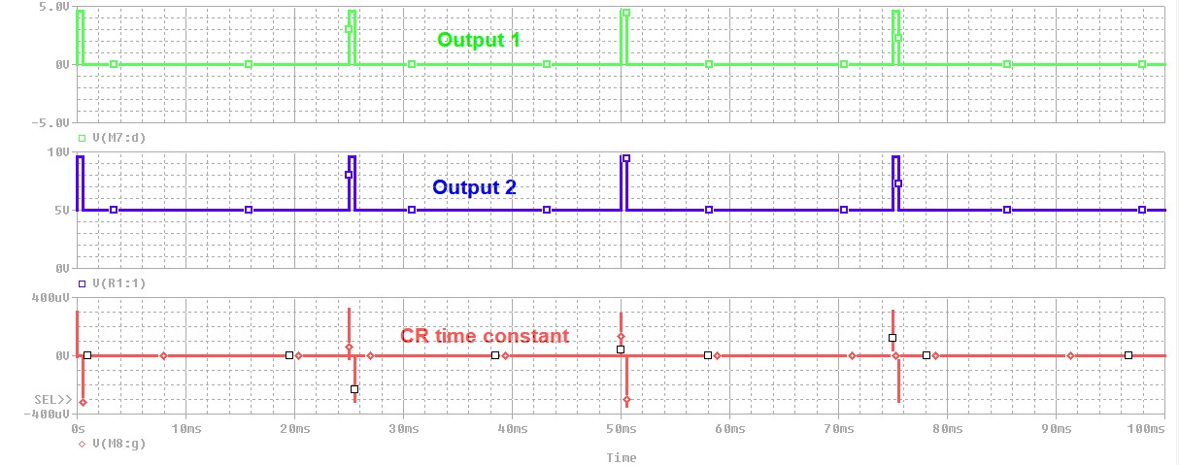

**Figure 5.6: Monostable Multivibrator with 2 NOR gates @ T = 12\*tau cursor**